Bouldering
  - Why I like to climb but hate to fall

Introduction
Bouldering is indoor climbing, at fallable hights. It involves problem solving, technique and building finger and grip strength.

I climb at least once a week and have made reasonable progress over the last year. The community is really friendly and people are always encouraging and willing to offer tips.

Grades
In climbing there are different challenge levels to different climbs, and climbs are given grades so climbers know what challenge to expect.
…

Equipment
The time you climb you will probably just rent some shoes and a chalk bag, but once you decide you want to do it regularly you’ll want to buy your own.
..

Shoes
Proper climbing shoes allow your feet to grip the holds. Your whole weight can be supported by tiny fingertip size holds with a good shoe with the correct fit.
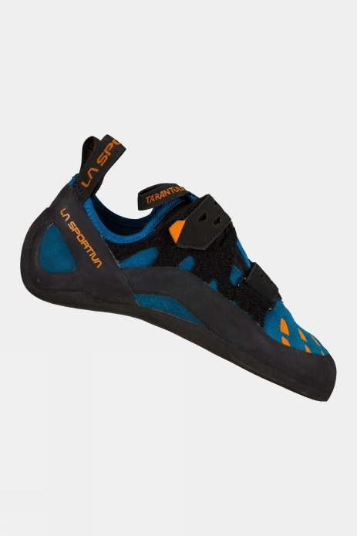

Chalk
